Learning Objectives:
- Identify the current state of facility asset management
- Understand what a high performance maintenance organization is
- Comprehend metric calculations for high performance maintenance organizations
- Prepare goals and metrics to create a high performance maintenance organization

Cost:
This complete executive level two day program is $1,499. This includes continental breakfast and lunch both days plus all program materials needed.

Program Format:
This program will take place over two days in either San Diego or Orlando. The program will include lectures, instructor lead group discussion, and small group work.

Program Details:
- The program will take place entirely at either the DoubleTree Orlando or the DoubleTree San Diego.
- All necessary program materials will be provided on-site.
- Professionals participating in the program will receive course materials in a two-ring binder.

Prerequisites:
There are no prerequisites for this program. Anyone is allowed to registered and attend.

Satisfactory Requirements for CEU: (the following requirements are mandatory to receive the IACET CEU’s offered)
- You must be present for over 90% of the time at the program.
- You must completed all on-site worksheets

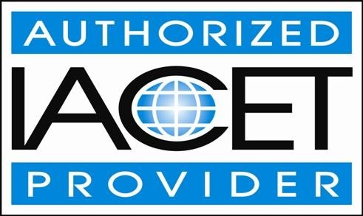
Trade Press Publishing Corporation has been approved as an Authorized Provider by the International Association for Continuing Education and Training (IACET), 1760 Old Meadow Road, Suite 500, McLean, VA 22102. Trade Press Publishing Corporation is authorized by IACET to offer 1.1 CEUs for this program.

Who Should Attend …?
This event was designed for anyone who has a stake in building a world-class maintenance organization.
Building Owners
Developers
Superintendents of Schools
Vice Presidents and Directors of:
Facilities & Buildings
Real Estate
Energy Services
Facilities Engineering
Design & Construction
Directors and Managers of:
Maintenance
Engineering
Facilities Maintenance
Building & Grounds
Building/Plant Services

Statement of Nondiscrimination:
Trade Press Publishing Corporation is committed to providing an educational opportunity for all persons and admits students or any race, color, gender, sexual preference, age, non-disqualifying handicap, religion or creed, or national or ethic origin.

